Operation
&
Service Manual
Telescopic
Conveyor
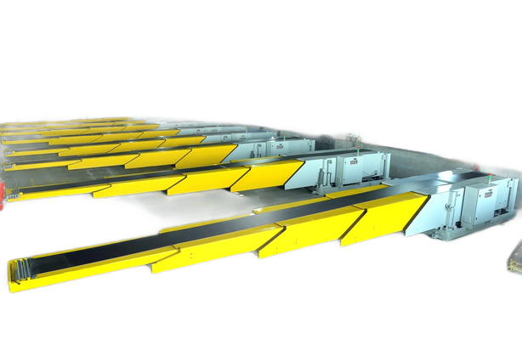
CAPACITY :- 30 Kg/Mtr
SL NO :- NTTC/ATS/01/12/001/01/21
YEAR OF MFG :- 11-DEC-2020/2021
CLIENT :- ATS CONVEYOR INDIA PVT LTD

TABLE OF CONTENT
Sr. No. | DESCRIPTION
1. | Introduction
2. | General Instruction
3. | Operating
4. | Maintenance Instruction
5. | Trouble Shooting
6. | Assemblies & Spare Part List
A. | Dispatch and unloading
B. | Ordering of spares

- INTRODUCTION

NIHVA telescopic conveyor – NIHVA designed the customized telescopic conveyor according to you required weight and speed to improve both productivity and the work environment NIHVA telescopic belt conveyor is an effective and ergonomic alternative to labour-intensive routines. NIHVA telescopic belt conveyors can be used to load/unload any type of loose-loaded cargo - typically parcels boxes, bags, loose items, sacks, tires and so many varieties of material.

NIHVA telescopic conveyors in India features
- Can be customized as per application
- Considered maximum safety
- Side panel, boom support,
- Belt speed 33m per minute
- Push button controls
- Ideal for boxes, bags, totes and loose items
- Reversible belt direction
- Front led lighting as standard
- Emergency stops in three positions
- Soft start motor and belt
- Variety of models and options available NIHVA telescopic conveyor benefits:
- Save human efforts by minimizing manual handling
- Save time
- Low energy cost
- Design based on safety and easy operate

2. GENERAL INSTRUCTIONS

2.1 Important
2.1.1 All designated operators of this equipment must read, understand and familiarize themselves with the content of this manual before operating the equipment.
2.1.2 No modification or alteration to the equipment or its part may be done, either temporarily or as permanent measure, without the written consent of the manufacture, M/s. NIHVA TECHNOLOGY PVT. LTD. Any violation of this requirement would void the warranty on the equipment.
2.2 Responsibility
2.2.1 The equipment should be handled with care and always operated in a responsible manner.
2.2.2 Follow all the safety norms, in vogue, when operating the equipment.
2.2.3 Not adhering to correct operating procedure or maintenance and carrying out repairs to the equipment through person not qualified or trained by the company may result in damage to the equipment. When necessary, call for our technical assistance.
2.2.4 Check the equipment and its functioning every day, prior to starting your work. Do not operate the equipment if any defect is noted. Report the defect to your superior.
2.2.5 Always ensure that the specification label is on the equipment. Note the rated capacity of the equipment and NEVER OVERLOAD the equipment.
2.3 Working Area
2.3.1 The equipment is designed for working on evenly distributed load so that the conveyor must be loaded centrally and uneven loading should be avoided which will cause uneven stressing of load members and jamming the belt.
2.3.2 Presence of other living being should not be permitted within the path or in the area where material is being moved, loaded and unloaded.
2.4. Working Area
2.4.1 Do not operate the equipment unless you are not familiar with the controls and operating procedure and are confident of handling the equipment.
2.4.2 Only authorized and trained personnel should operate the equipment.
2.4.3 Never exceed the rated capacity of the equipment. The capacity is mentioned on the nameplate.
2.4.4 Control Panel is provided with push buttons, functioning as:
Telescopic Forward | Move Boom In Forward (inching operation)
Telescopic Reverse | Move Boom In Reverse (inching operation)
Hydraulic Up | Lift boom up (inching operation)
Hydraulic Down | Lower boom down (inching operation)
Belt Forward/Reverse | Move belt in forward/reverse
Belt Stop | Stop belt movement
Speed Regulator | Regulate speed of belt
Mains On/Off switch | Start/stop control panel operation
Emergency Cut Off | Stop all running operations
2.4.5 Boom Forward / Reverse: For boom forwarding press and hold “TELESCOPIC FORWARD” button till you reach the desired position and for reversing press and hold the “
TELESCOPIC REVERSE” button till you reached the desired position.
2.4.6 Boom Up / Down: For boom up, press and hold the “HYDRAULIC UP” button till you reach position and reversing, press and hold “HYDRAULIC DOWN” button till you reach the desired position.
2.4.7 Belt Forward / Reverse / Stop: For belt running forward direction press “BELT FORWARD” button and for reversing press “BELT REVERSE” button. Pressing “BELT STOP” button stops the belt movement.
NOTE: Before changing the direction, it is mandatory that you should press “BELT STOP” button.
2.4.8 Belt Speed: Rotate speed regulator to adjust desired speed of belt.
2.4.9 Use “EMERGENCY CUT-OFF SWITCH” to stop all running operations in case of emergency and after the operations is over.
2.4.10 Pendent Box is provided for operational ease on one side in extreme front boom with push buttons.
Telescopic Forward | Move boom in forward (Inching Operation)
Telescopic Reverse | Move boom in reverse (Inching Operation)
Hydraulic Up | Lifts boom up (Inching Process)
Hydraulic Down | Lowers boom down (Inching Process)
Belt Forward | Move belt in forward
Belt Reverse | Move belt in reverse
Belt Stop | Stop belt movement
Emergency Cut Off | Stops all running operations
Light | Glow front light

2.4.10. a. Boom Forward/ Reverse: Same as clause no. 2.4.5
2.4.10. b. Boom Up / Down: Same as clause no. 2.4.6
2.4.10. c. Belt Reverse / Forward / Stop: Same as clause no. 2.4.7
2.4.10. d. Use EMERGENCY CUT-OFF SWITCH to stop all running operations in case of emergency and after the operation is over.
2.4.10. e. Load and unload the material centrally on the belt.
2.4.10. f. Lower the boom to the resting position when not in use.

3. OPERATING
3.1 Starting
3.2 Before starting ensure that:
- There is no leakage from the hydraulic connections and emergency safety release valve is in close position.
- The electric connections are in proper condition.
- Emergency Cut Off switch is released.
- Areas around conveyor are clear of obstructions and debris.
- Loose items including hair, fingers, clothing, gloves etc. are clear of moving parts.
- All guards are fitted and are secure.
3.3 Connect 3 phase 415V 4 wire supply to the panel through cable top.
3.4 Switch on the power supply from the control panel.
3.5 Follow the operating instructions described in clause no. 2.4.4 to 2.4.11.
3.6 If power fails when boom lifted at top position, open the “EMERGENCY PRESSURE RELEASE VALVE” slowly for lowering the boom to the rest position.

4. MAINTENANCE INSTRUCTION
WARNING
Under no circumstances any person should not enter the area below the conveyor or attempt any services or adjustment to the hydraulic system without fitting securely positioned chocks. Failure to observe this warning could result in SEVERE CRUSHING INJURY OR DEATH.
4.1 Daily check.
4.1.1 Check hydraulic piping for leakages, if any tighten the joint to eliminate the leakage
4.1.2 Check electrical connections for its proper working and functioning of the interlocks for safety.
4.1.3 Check level of hydraulic oil.
4.2 Monthly check
4.2.1 Lubricate at all the hinged joints and rollers and guideways by using recommended using grease gun.
4.2.2 Tighten all bolts, fasteners, electrical connection. Check for performance of all safety devices.
4.2.3 Check for performance of all limit switches.
4.3 Annual check
4.3.1 Do the complete overhaul of the equipment.
4.3.2 Clean and flush hydraulic tank and distribution system and refill with fresh oil. Check for leakage and replace seals as necessary.

RECOMMENDED LUBRICANTS

GREASE: -
ESSO BEACON-2
CASTROL PETROLEUM CASTRDE ASELM
BHARAT PETROLEUM BHARAT UNIVEX “A”

HYDRAULIC OIL: -

SERVO-68
ENCLO-68

5. TROUBLE SHOOTING
If belt ceases to operate:
- Check all emergency stops
- Check power supply
- Check for foreign objects jamming belt
- Check for electrical or electronic overloads
- Check for belt slippage with motor running
If the conveyor will not extend or retract:
- Check all emergency stops
- Check power supply
- Check extension stop bar for correct operation
- Check internally for foreign objects jamming path
- Check for drive coupling slipping
- Check extension drive chain for breakage
- Check for electric overloads
- Check for obstruction activity sensors (fitted front of conveyor)
If conveyor will not tilt up or down:
- Check all emergency stops
- Check power supply
- Check for oil leaks
- Check for obstructions
- Check emergency pressure release valve position is correct
- Check for electrical overloads

A. Dispatch & Unloading
1. Loading, for dispatch, will be our responsibility. On receipt of the Telescopic Conveyor at site, please check and ensure that the there is no physical damage to the equipment.
2. While unloading the equipment from the transporting vehicle, please ensure to use slings with rated capacity higher than the gross weight of the telescopic condition.
3. Slings MUST be hooked ONLY at specified positions. Improper sling position or improper slinging could cause damage to the equipment.

B. Ordering of Spares
1. When ordering for spare, please specify the following in your purchase order.
- Equipment Name
- Equipment Serial No.
- Part Name / Description
- Part Number
- Quantity Required
- Delivery Period / Time
- Mode of Dispatch

This would avoid ambiguity and help us serve you better.

6. ASSEMBLY AND PARTS.
GENERAL ASSEMBLY

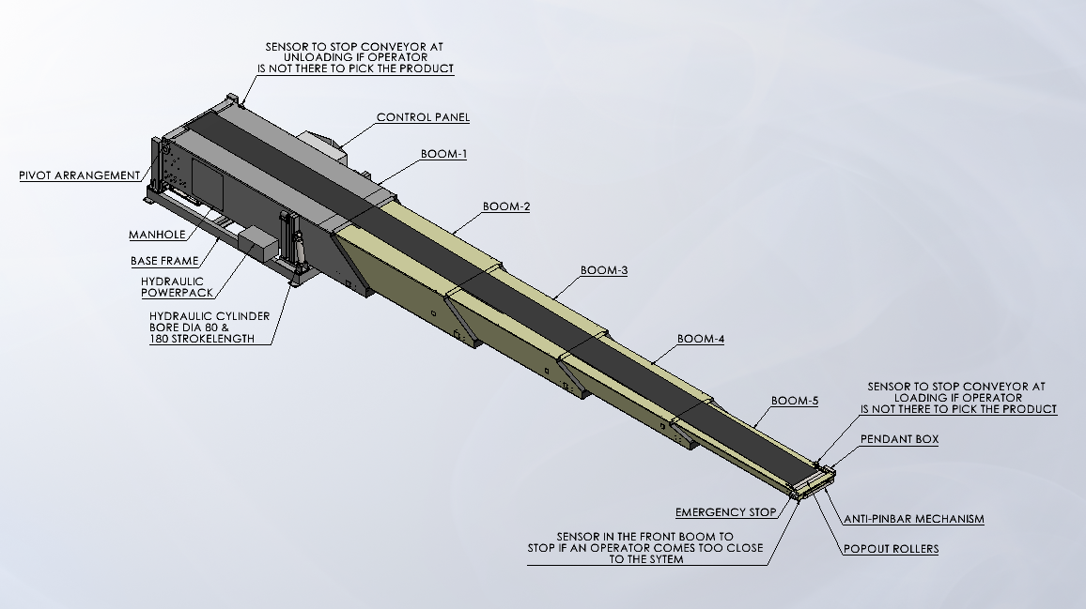

PARTS:-
BOOM-1
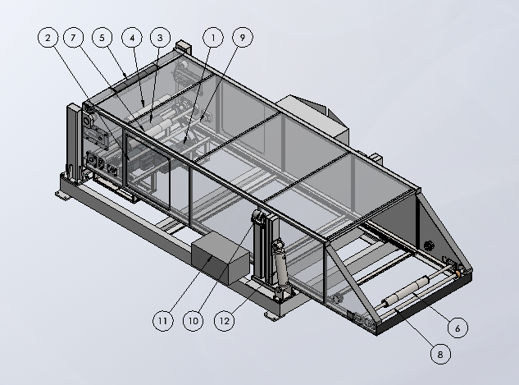
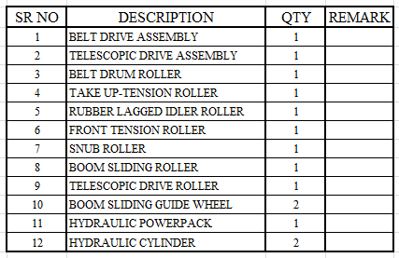

BOOM-2
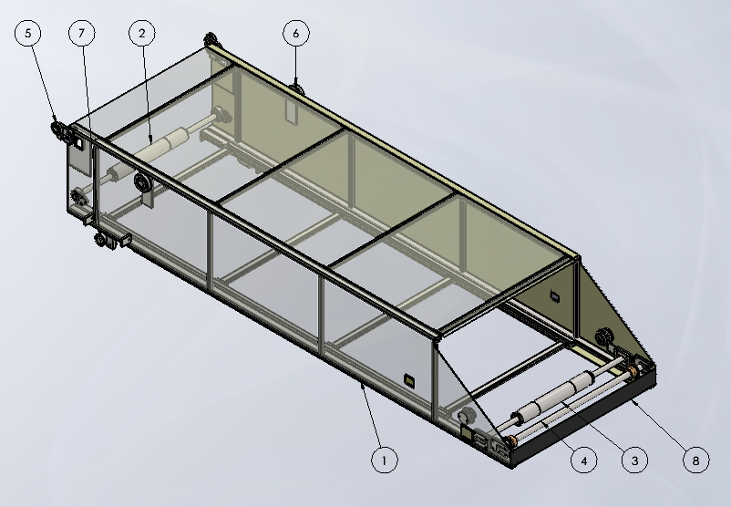
BOOM 2 ASSEMBLY

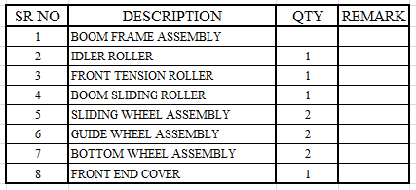

BOOM-3
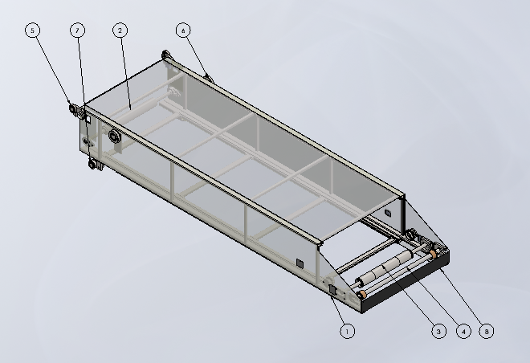

BOOM 3 ASSEMBLY

BOOM-4
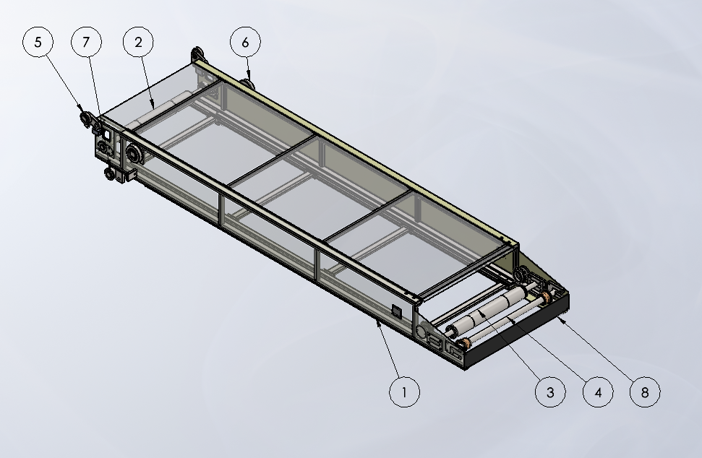

BOOM 4 ASSEMBLY

BOOM-5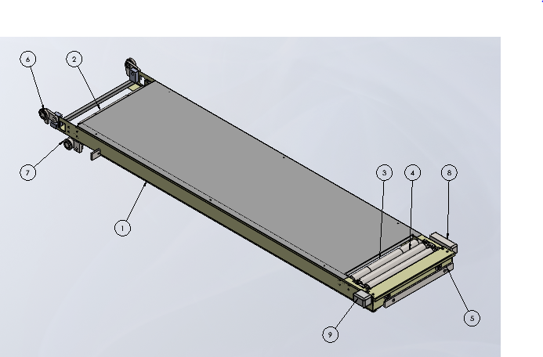
BOOM 5 ASSEMBLY
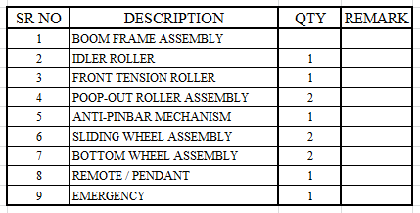

Belt Drive Assembly

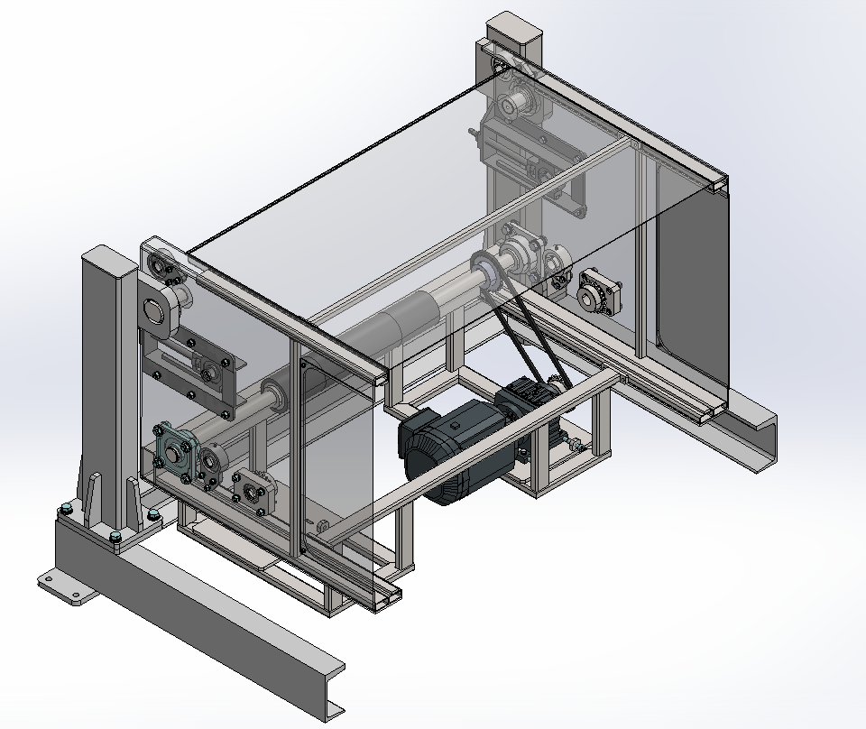

Telescopic Drive Assembly
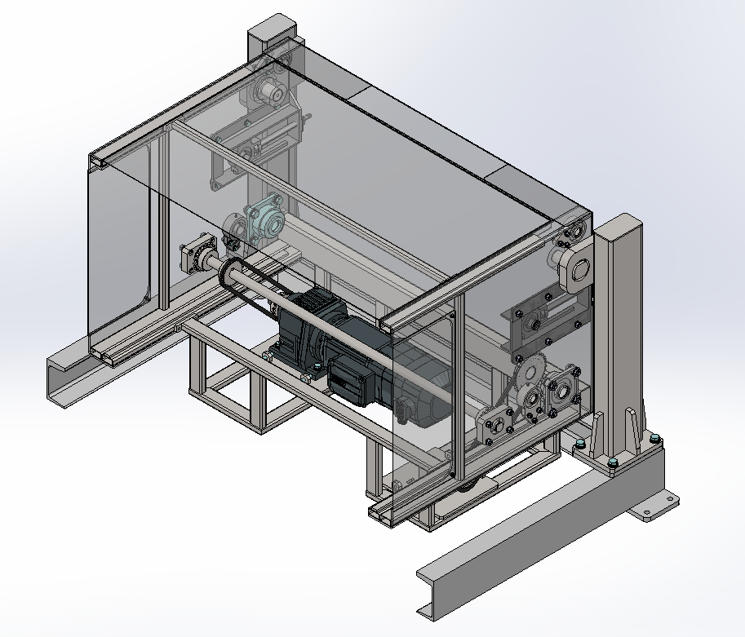

Hydraulic Power pack Arrangements

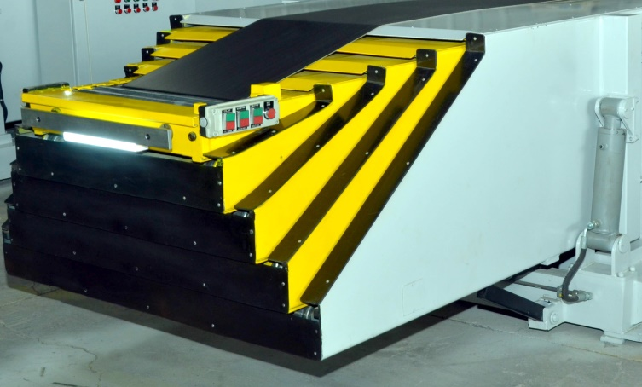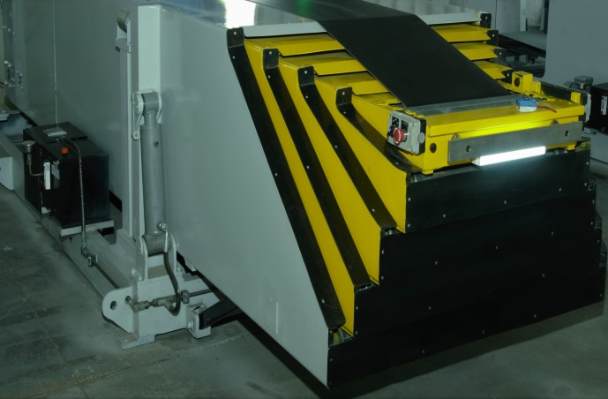

SR NO | DESCRIPTION | QTY
1 | G 1/4 M X G 3/8 M BRASS CONNECTOR | 1NO
2 | HOSE PIPE WITH ONE SIDE STRAIGHT AND ONE SIDE 90° BEND BOTH SIDE G 3/8 F 550 +/- 25MM LENGTH (160 BAR) | 1NO
3 | G 3/8 M X G 3/8 M BRASS CONNECTOR | 1 NO
4 | MS SEAMLESS PIPE ∅12 X 1.5 THK X 4 MTR | 1NO
5 | FERRULE FITTING (BRASS) G 3/8 F | 8NOS
6 | ELBOW G 3/8 M X G 3/8 M (BRASS) | 3 NOS
7 | TEE FITTING G 3/8 M X G 3/8 M X G 3/8 M | 2NOS
8 | HOSE PIPE WITH SIDE STRAIGHT AND ONE SIDE 90° BEND BOTH SIDE G 3/8 F 300 +/- 10MM (160 BAR) | 2NOS
9 | G 3/8 M X G 3/8 M BRASS CONNECTOR | 2NOS
10 | PIPE CLAMPING OD-∅12 MM -10NOS | 10NOS

TELESCOPIC CONVEYOR OPERATING BUTTONS,HARTING CONNECTION DETAILS_1

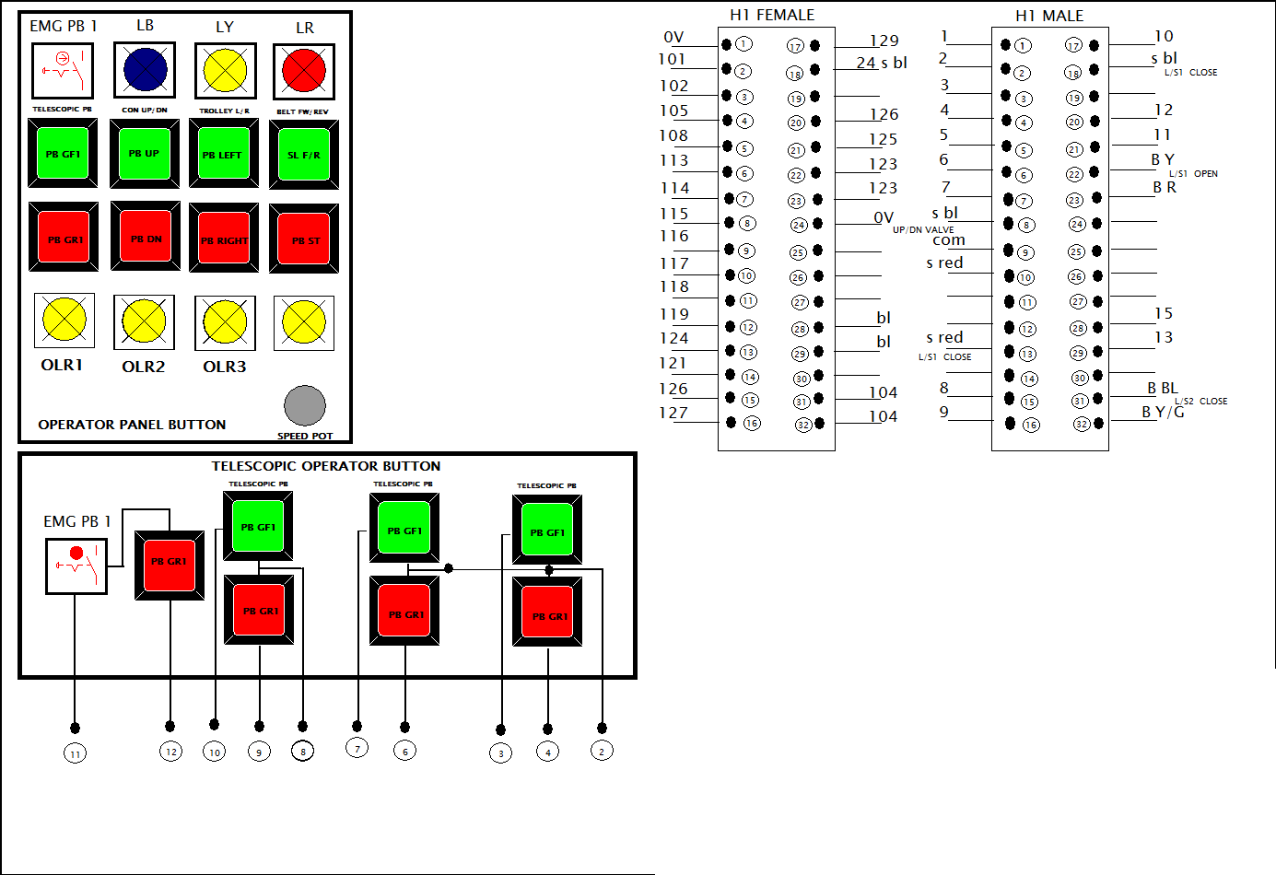

TELESCOPIC CONVEYOR POWER CONTACTOR CIRCUIT-1

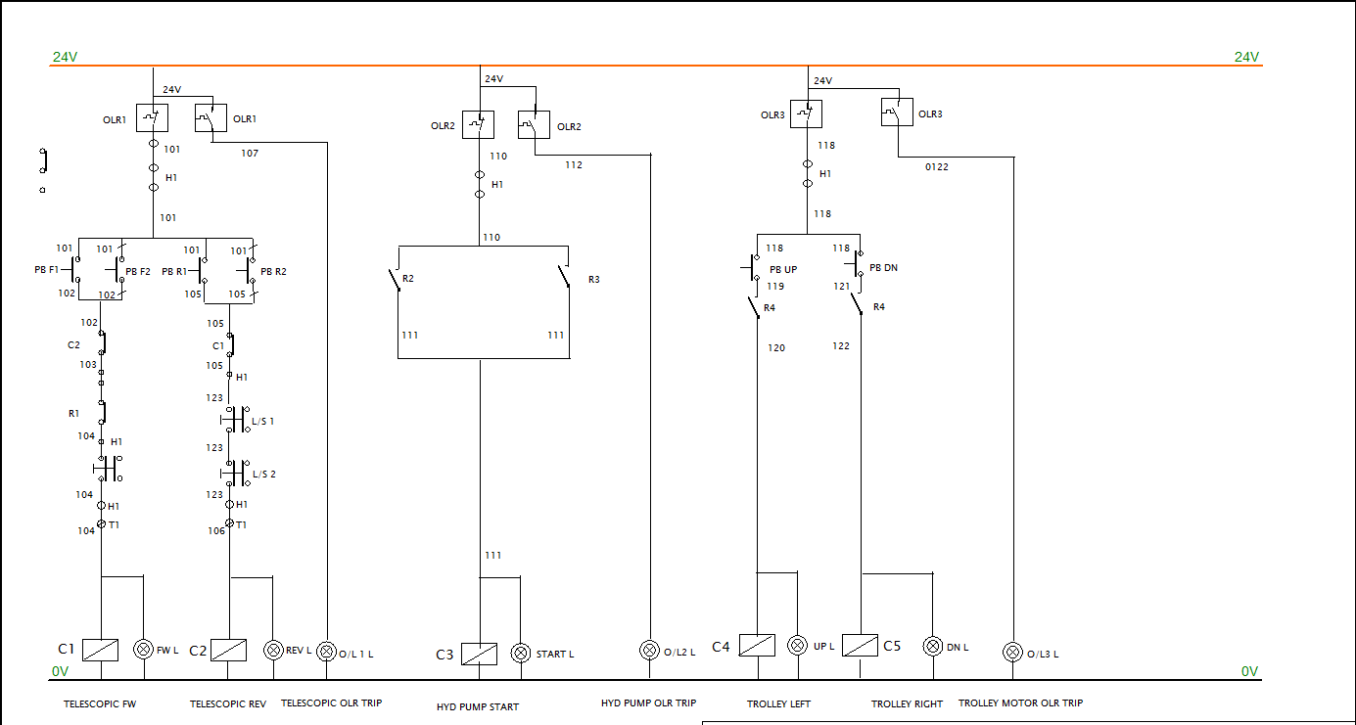

TELESCOPIC CONVEYOR POWER DISTRIBUTION-1

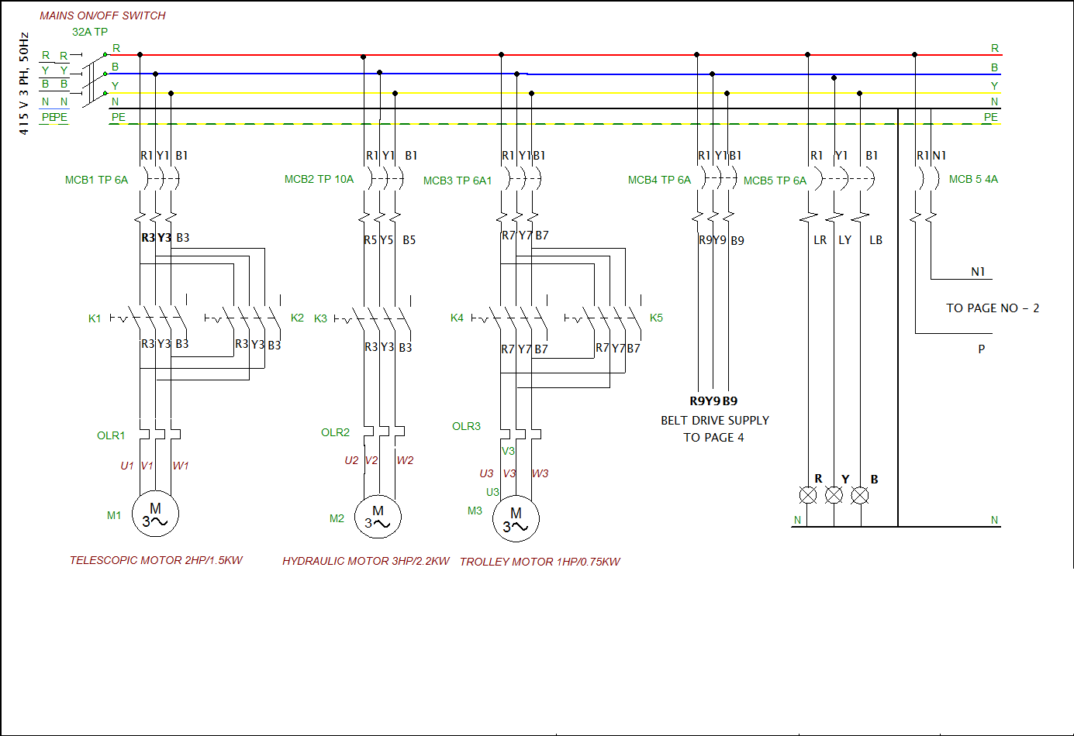

BELT ASSEMBLY
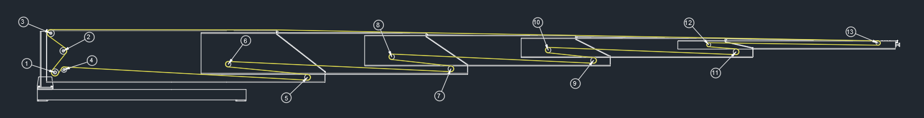

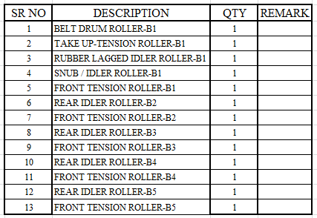

CHAIN ASSEMBLY

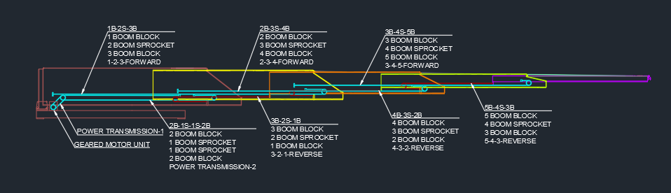

HYDRAULIC ASSEMBLY
HYDRAULIC ASSEMBLY
SR. NO. | DESCRIPTION | QTY | REMARK
 | HYDRAULIC CYLINDER | 2
 | SOLENOID VALVE | 1
 | EMERGENCY PRESSURE VALVE RELEASE | 1
 | OIL TANK | 1
 | MOTOR | 1
 | PRESSURE GAUGE | 1
 | HYDRAULIC HOSE PIPE | 1

